Medical Inventory Management - CRM

Project Documentation  
Naanmudhalvan Course

Team members – Hashim p a

Haya ashraf a

Isham aslam

Jasil Muhammed c m

# Project Overview

The Medical Inventory Management CRM is built on the Salesforce platform to streamline the process of managing medical products, suppliers, purchase orders, and inventory transactions. This CRM provides businesses with a centralized system to monitor stock levels, manage supplier data, automate calculations, and generate insightful reports and dashboards. It enables better decision-making and efficient handling of medical inventory, addressing the growing need for automated solutions in healthcare inventory management.

# Objectives

The primary objective of this CRM is to simplify and automate medical inventory management processes. Key goals include improving stock tracking, streamlining purchase order processing, enhancing supplier management, and providing real-time data through reports and dashboards. By implementing Salesforce-based automation, businesses gain better control over operations, reduce manual errors, and improve customer satisfaction.

# Salesforce Components Implemented

## 1. Objects Created

The following custom objects were created to manage medical inventory data efficiently:  
• Product: Stores details of available medical products.  
• Supplier: Maintains supplier information and contact details.  
• Purchase Order: Tracks purchase requests, order status, and related products.  
• Inventory Transaction: Manages stock inflow and outflow.  
• Order Item: Stores product-specific details for each purchase order.

## 2. Fields & Relationships

Various custom fields, formula fields, currency fields, and lookup relationships were created to manage data seamlessly. Examples include:  
• Formula Fields: Unit Price, Amount, Total Order Cost.  
• Lookup Relationships: Linking Purchase Orders with Suppliers and Products.  
• Picklist Fields: Used in Inventory Transactions to manage transaction types.

## 3. Tabs & Lightning App

A custom Lightning App named 'Medical Inventory Management' was created, integrating relevant object tabs such as Products, Suppliers, Purchase Orders, Inventory Transactions, and Reports for easy navigation.

## 4. Validation Rules

Validation rules were implemented to ensure data integrity and accuracy:  
• Expected Delivery Date Validation: Ensures that the delivery date cannot be earlier than the order date.  
• Quantity Validation: Prevents negative or zero quantity values in order items.

## 5. Automation (Flows & Triggers)

Several automation components were implemented:  
• Flows: Used to automatically update Actual Delivery Date in related objects.  
• Apex Triggers: A trigger was created to calculate the Total Amount in Order Items automatically.

## 6. Profiles, Roles & Permission Sets

Custom profiles and roles were created to manage user access:  
• Inventory Manager Profile: Full access to product and inventory management.  
• Purchase Manager Profile: Manages purchase orders and supplier data.  
• Permission Set: Grants additional permissions for specific fields and objects.

## 7. Reports & Dashboards

Two custom reports were created:  
• Supplier-Based Purchase Orders Report: Displays purchase details grouped by suppliers.  
• Complete Purchase Details Report: Provides a summary of all purchase orders and their statuses.  
Additionally, a custom dashboard was designed to provide a visual representation of purchase orders and inventory status.

# Screenshots

Insert Salesforce Setup and Configuration Screenshots for each feature here.

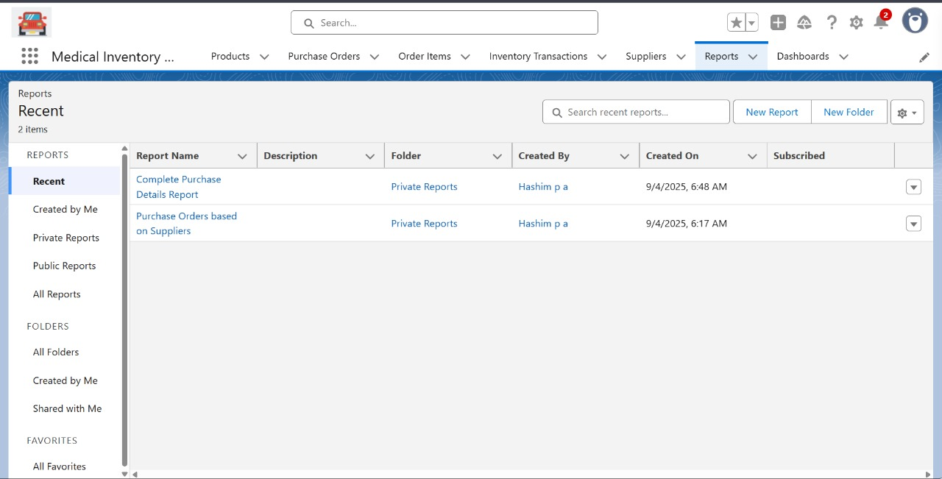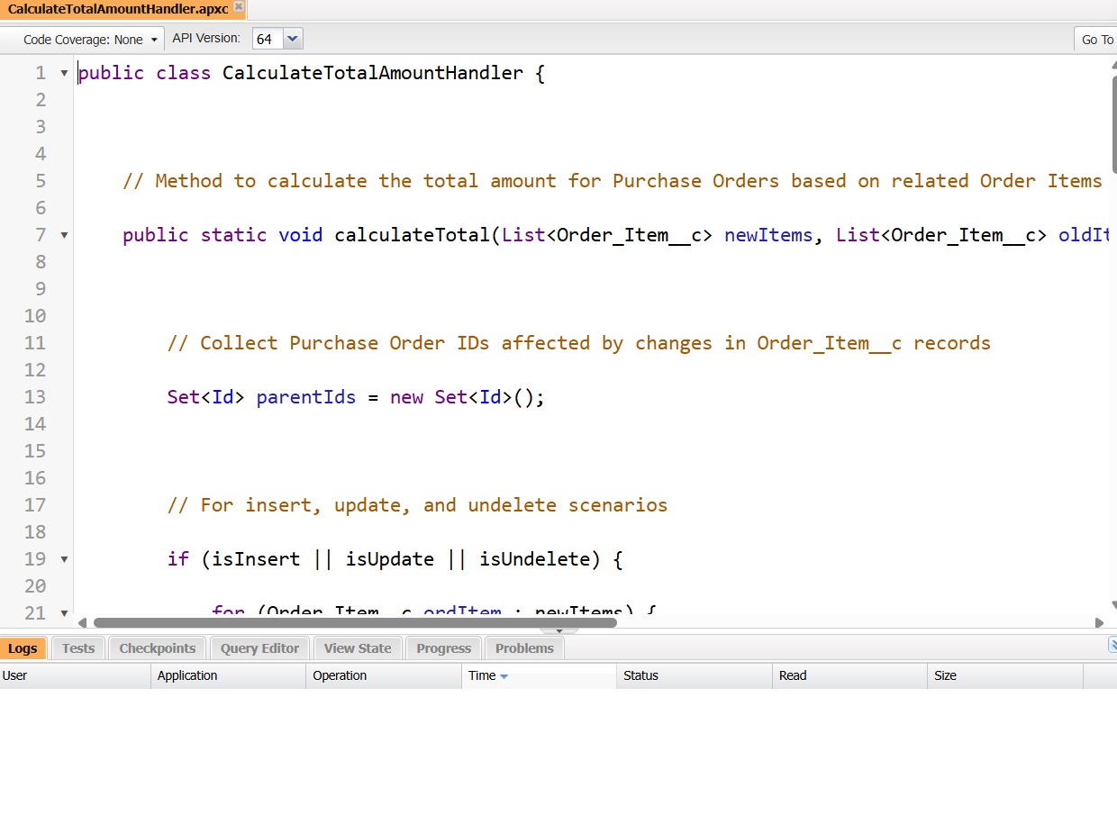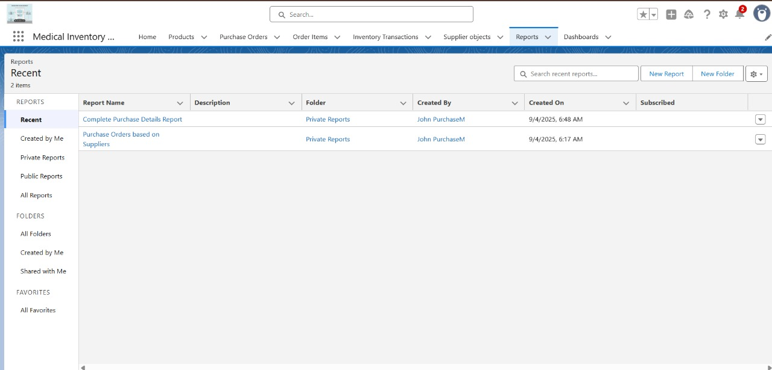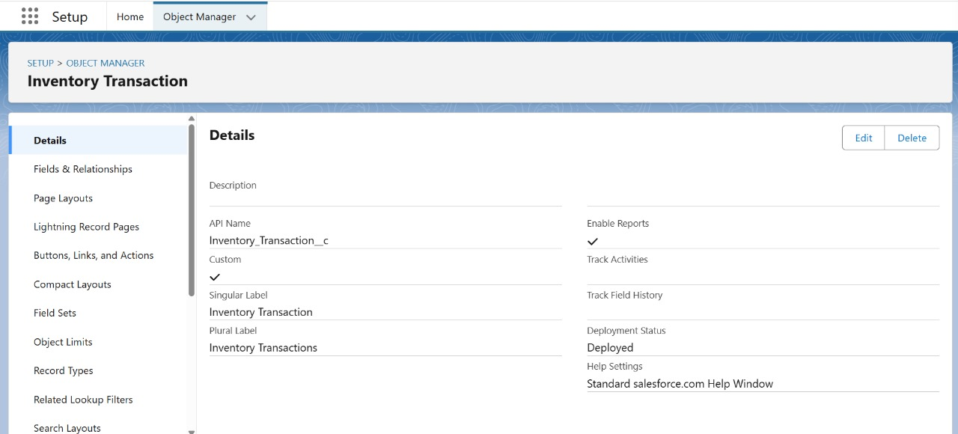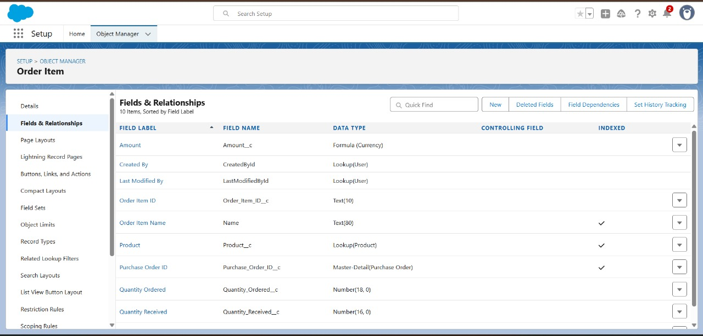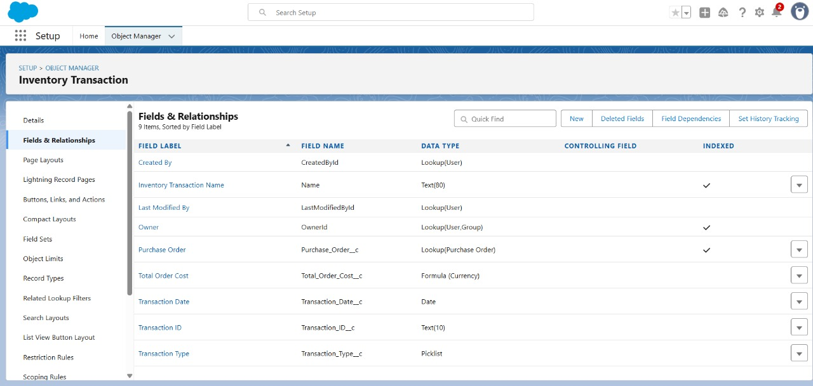

# Testing Approach

Testing was performed for all configured components to ensure smooth functionality:  
• Flows: Tested using sample purchase orders to confirm automatic updates.  
• Reports & Dashboards: Verified accurate data grouping and calculations.  
• Triggers: Tested positive and negative scenarios for amount calculations.  
• Validation Rules: Ensured invalid data entries are restricted.

# Future Enhancements

Possible future enhancements include:  
• Integration of AI-powered stock prediction.  
• Chatbot integration for supplier and customer queries.  
• Mobile app support for real-time inventory tracking.

# Conclusion

The Medical Inventory Management CRM successfully demonstrates the implementation of Salesforce components to manage products, suppliers, purchase orders, inventory transactions, and reports. By leveraging automation, validations, and dashboards, this project improves operational efficiency, data accuracy, and decision-making capabilities.